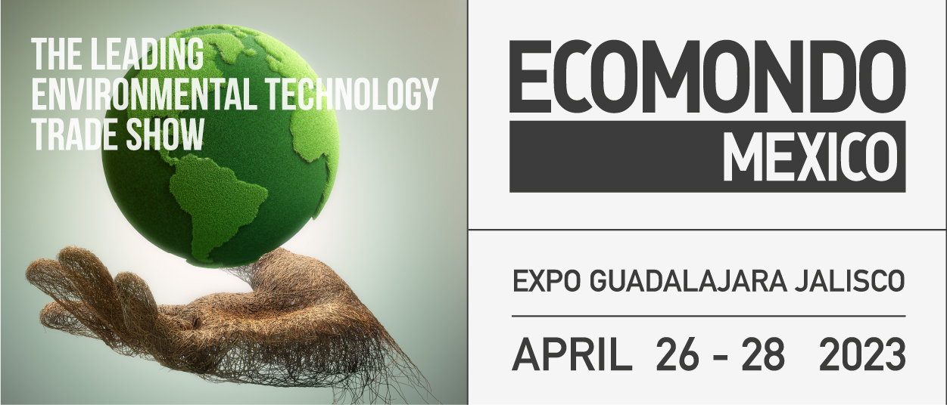

press release
(English translation)

ECOMONDO MEXICO, IEG: A GREEN ECONOMY PLATFORM IN NORTH AMERICA

- From 26th to 28th April, at Expo Guadalajara, a new venue for the 2nd edition of the circular economy exhibition organised by Italian Exhibition Group and Deutsche Messe

- 18 Italian companies will be exhibiting, 13 in the collective organised by the Italian Trade Agency

https://hfmexico.mx/ecomondo

Guadalajara (Mexico)/Rimini 18th April 2023 – Mexico is getting ready to turn green with Ecomondo gathering together the circular economy community in Guadalajara from 26th to 28th April. The second edition of Ecomondo Mexico, organised by Italian Exhibition Group and Deutsche Messe at the Expo in the capital of the state of Jalisco and the country's second largest metropolis, is about to kick off. Ecomondo Mexico, whose objective is networking between Mexican and international companies, investors and business partners, is to be held at Expo Guadalajara alongside Solar+Storage Mexico, the renewable energy event also organised by Deutsche Messe and IEG together with partners Snec PV Power Expo and RE+ Events.

STATEMENTS
«There is a growing awareness that environmental sustainability is not an option. It brings us all together, at any latitude, towards the common goal of safeguarding the Planet. It is therefore a great pleasure to bring Ecomondo's expertise to Mexico and to contribute in the technological development of the nation’s green economy through a collective effort involving IEG, ITA-Italian Trade Agency and the Italian Embassy in Mexico City,» says Italian Exhibition Group President, Lorenzo Cagnoni.
«Ecomondo Mexico has moved to Guadalajara, a barycentric metropolis for the domestic economy and important in the perimeter of the NAFTA and now USMCA trade agreement. The US Administration is setting the stage for a green acceleration, which will also be a driving force for Mexico: an opportunity for Italian companies, which have only recently started to address this market,» adds IEG CEO, Corrado Peraboni.

OPPORTUNITIES FOR ITALIAN GREEN TECHNOLOGIES
Eighteen Italian companies will be exhibiting at Ecomondo Mexico: 13 of these will be part of the collective in the hall organised by ITA-Italian Trade Agency. They will be joined by Canadian, US and European exhibitors to complete the industrial platform of the event, which will be divided into five product areas: Waste and Resources, Water and Monitoring, Bioenergy, Wind Energy, and Sustainable Mobility together with Smart City. With around 130 million inhabitants Mexico, according to the World Bank, is the second largest economy in Latin America and among the 15 largest in the world. It is the second largest market for Italian exports to the Americas after the USA. Its growth rate exceeded 3 per cent in 2022. According to the Ministry of Foreign Affairs and International Cooperation, about 150 Italian companies have set up production plants in the country. For the period 2021-25, the Global Green Growth Institute is supporting the Mexican government with projects for the implementation of the green economy, biodiversity, waste management, electric mobility and climate finance.

CONFERENCES, GOOD ITALIAN AND MEXICAN PRACTICES
With 25 years of editions in Italy, one of the special features of Ecomondo’s expertise lies in the quality of the scientific offer included in its conference programme organised by the Technical-Scientific Committee directed by Fabio Fava from Bologna University. On the topics of waste and the water cycle, Ecomondo Mexico has respectively engaged the expertise of TSC members Marco Ricci and Francesco Fatone. In Guadalajara, Ecomondo Mexico will boast a series of conferences that, on the one hand and with a global approach, will take stock of the latest green technologies such as “biochar”, while on the other, in the ITA- Italian Trade Agency hall, will focus on a “bilateral” presentation of good practices and management experiences from both Italy and Mexico on the themes of waste management or the challenges posed by water resources today.

PRESS CONTACT ITALIAN EXHIBITION GROUP media@iegexpo.it
Elisabetta Vitali, head of corporate communication and media relations; Marco Forcellini, press office manager;
Silvia Giorgi, international press office coordinator;

This press release contains forecast elements and estimates that reflect the management’s current opinions (“forward-looking statements”), particularly regarding future management performance, realization of investments, cash flow trends and the evolution of the financial structure. For their very nature, forward-looking statements have a component of risk and uncertainty, as they depend on the occurrence of future events. The effective results may differ (even significantly) from those announced, due to numerous factors, including, only by way of example: food service market and tourist flow trends in Italy, gold and jewellery market trends, green economy market trends; the evolution of raw material prices; general macroeconomic conditions; geopolitical factors and evolutions in the legislative framework. Moreover, the information contained in this release does not claim to be complete, and has not been verified by independent third parties. Forecasts, estimates and objectives contained herein are based on the information available to the Company as at the date of this release.

